**Linear Regression on Salary_Data.csv**

**Predicting Salary based on experience**

**Full Code:**

library(ggplot2)

data = read.csv("Salary_Data.csv")

head(data)

dim(data)

View(data)

scatter.smooth(x=data$Salary, y=data$YearsExperience, main="Salary ~ YearsExperience")

ggplot() +

geom_point(aes(x = data$Salary,

y = data$YearsExperience), colour = 'violet') +

ggtitle('Salary ~ Experience') +

xlab('Salary') +

ylab('Experience')

cor(data$Salary, data$YearsExperience)

lm_model = lm(formula = Salary ~ YearsExperience, data = data)

summary(lm_model)

#Prediction for 1 year of experience

n_1 <- data.frame(YearsExperience=c(1))

pred = predict(regressor, newdata = n_1)

paste("For 1 year of exp, Salary would be:", pred)

#Prediction for 5 year of experience

n_2 <- data.frame(YearsExperience=c(5))

pred = predict(regressor, newdata = n_2)

paste("For 5 year of exp, Salary would be:", pred)

#Prediction for 7 year of experience

n_2 <- data.frame(YearsExperience=c(7))

pred = predict(regressor, newdata = n_2)

paste("For 7 year of exp, Salary would be:", pred)

**Code:**

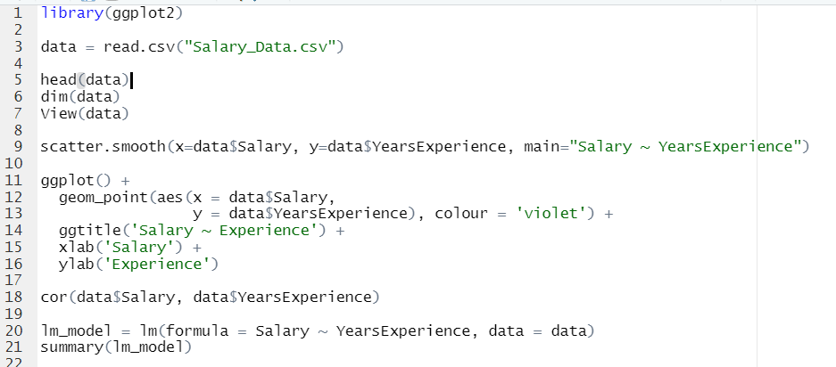

**Output:**

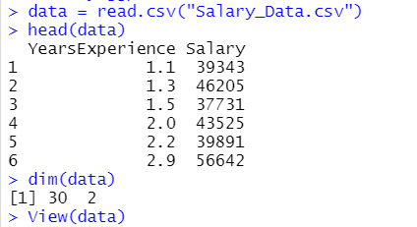

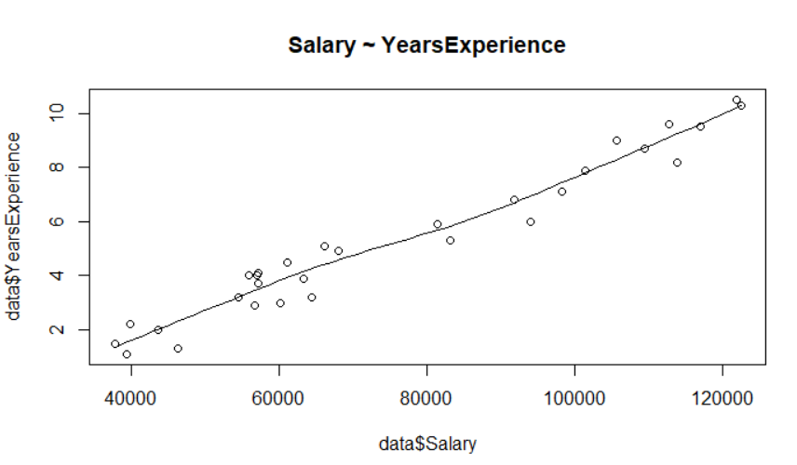

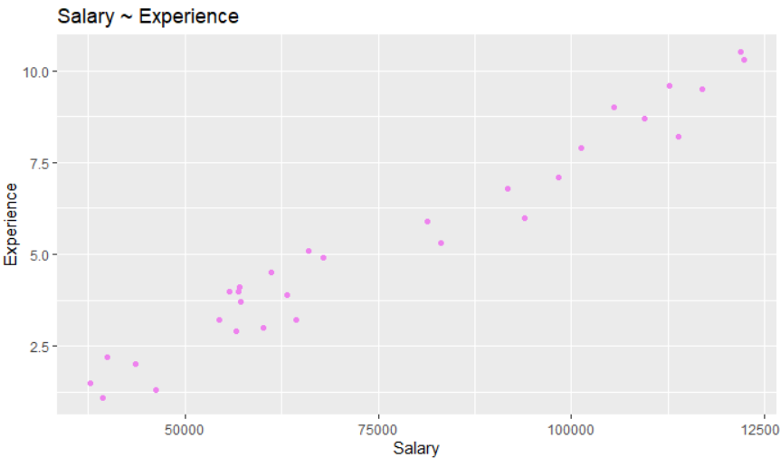

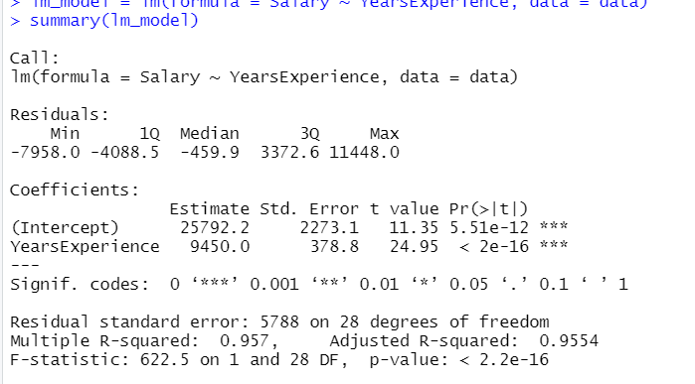

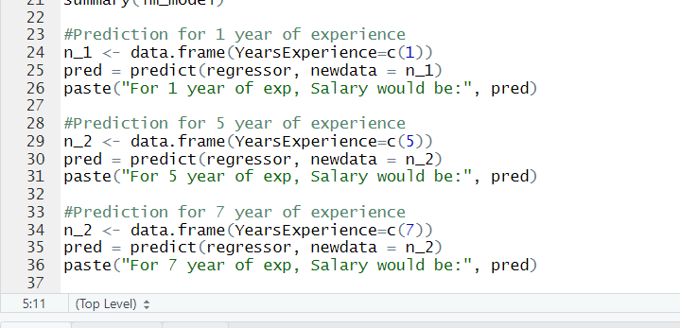

**Output:**

